Aaronea Wiggins

CTEC 298 – Dr. Bemley

April 3, 2025

Tutorial 1 – LearnPython

1. Hello World

1. Variables and Types

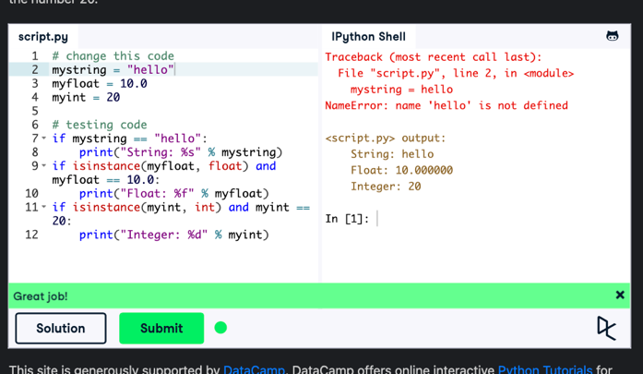

1. Lists

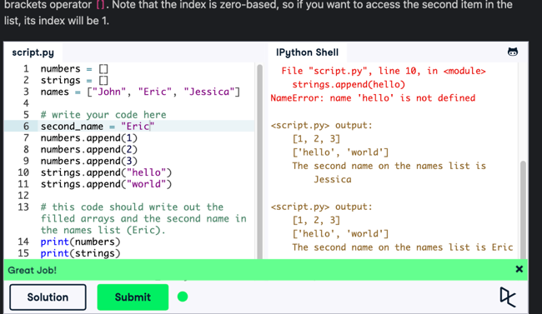

1. String Operators

1. String Formatting

1. Basic String Operations

